MODULE: 1

**Q 1. What is software? What is software engineering?**

**Ans.** In a computer system, the software is basically a set of instructions or commands that tell a computer what to do. In other words, the software is a computer program that provides a set of instructions to execute a users commands and tell the computer what to do. For example like MS-Word, MS-Excel, PowerPoint, etc.

**Software Engineering** The term **software engineering** is the product of two words, **software,** and **engineering.**

The **software** is a collection of integrated programs Software subsists of carefully-organized instructions and code written by developers on any of various particular computer languages. Computer programs and related documentation such as requirements, design models and user manuals.

**Engineering** is the application of **scientific**and **practical**knowledge to **invent, design, build, maintain,** and**improve frameworks, processes, etc.**

**Software Engineering** is an engineering branch related to the evolution of software product using well-defined scientific principles, techniques, and procedures. The result of software engineering is an effective and reliable software product.

**Q 2. Explain types of software**

**Ans.** **Types of Software**

**1.System Software**

* System Software
* Operating System
* Language Processor
* Device Driver

**2.Application Software**

* **General Purpose Software**
* **Customize Software**
* **Utility Software**

**System Software**

System software is software that directly operates the computer hardware and provides the basic functionality to the users as well as to the other software to operate smoothly. Or in other words, system software basically controls a computer’s internal functioning and also controls hardware devices such as monitors, printers, and storage devices, etc. It is like an interface between hardware and user applications, it helps them to communicate with each other because hardware understands machine language(i.e. 1 or 0) whereas user applications are work in human-readable languages like English, Hindi, German, etc. so system software converts the human-readable language into machine language and vice versa.

**Types of System Software**

It has two subtypes which are:

**1.Operating System:** It is the main program of a computer system. When the computer system ON it is the first software that loads into the computer’s memory. Basically, it manages all the resources such as computer memory, CPU, printer, hard disk, etc., and provides an interface to the user, which helps the user to interact with the computer system. It also provides various services to other computer software. Examples of operating systems are Linux, Apple macOS, Microsoft Windows, etc.

**2.Language Processor:** As we know that system software converts the human-readable language into a machine language and vice versa. So, the conversion is done by the language processor. It converts programs written in high-level programming languages like Java, C, C++, Python, etc(known as source code), into sets of instructions that are easily readable by machines(known as object code or machine code).

**3.Device Driver:** A device driver is a program or software that controls a device and helps that device to perform its functions. Every device like a printer, mouse, modem, etc. needs a driver to connect with the computer system eternally. So, when you connect a new device with your computer system, first you need to install the driver of that device so that your operating system knows how to control or manage that device.

**Application Software**

Software that performs special functions or provides functions that are much more than the basic operation of the computer is known as application software. Or in other words, application software is designed to perform a specific task for end-users. It is a product or a program that is designed only to ­­­full fill end-users’ requirements. It includes word processors, spreadsheets, database management, inventory, payroll programs, etc.

**Types of Application Software**

There are different types of application software and those are:

**1.General Purpose Software:** This type of application software is used for a variety of tasks and it is not limited to performing a specific task only. For example, MS-Word, MS-Excel, PowerPoint, etc.

**2.Customized Software:** This type of application software is used or designed to perform specific tasks or functions or designed for specific organizations. For example, railway reservation system, airline reservation system, invoice management system, etc.

**3.Utility Software:** This type of application software is used to support the computer infrastructure. It is designed to analyze, configure, optimize and maintains the system, and take care of its requirements as well. For example, antivirus, disk fragmenter, memory tester, disk repair, disk cleaners, registry cleaners, disk space analyzer, etc.

**Q 3. What is SDLC? Explain each phase of SDLC**

Ans. **The Software Development Life Cycle (SDLC)**is a process used by software development organizations to plan, design, develop, test, deploy, and maintain software applications.

The SDLC typically includes the following phases:

**1.**[**Requirements gathering and analysis:**](https://www.geeksforgeeks.org/requirements-gathering-introduction-processes-benefits-and-tools/)This phase involves gathering information about the software requirements from stakeholders, such as customers, end-users, and business analysts.

**2. Design:** In this phase, the software design is created, which includes the overall architecture of the software, data structures, and interfaces. It has two steps:

* **High-level design (HLD):** It gives the architecture of software products.
* **Low-level design (LLD):** It describes how each and every feature in the product should work and every component.

**3. Implementation or coding:** The design is then implemented in code, usually in several iterations, and this phase is also called as Development.

things you need to know about this phase:

* This is the longest phase in SDLC model.
* This phase consists of Front end + Middleware + Back-end.
* **In front-end:**Development of coding is done even SEO settings are done.
* **In Middleware:** They connect both the front end and back end.
* **In the back-end:** A database is created.

**4. Testing:**The software is thoroughly tested to ensure that it meets the requirements and works correctly.

**5. Deployment:** After successful testing, The software is deployed to a production environment and made available to end-users.

**6. Maintenance:**This phase includes ongoing support, bug fixes, and updates to the software.

There are **different**[**methodologies**](https://www.geeksforgeeks.org/5-most-commonly-used-software-development-methodologies/?ref=lbp) that organizations can use to implement the SDLC, such as**Waterfall, Agile, Scrum, V-Model**and**DevOps.**

**Q 4. What is DFD? Create a DFD diagram on Flipkart**

**Ans.** **DFD** is the abbreviation for **Data Flow Diagram**. The flow of data of a system or a process is represented by DFD. It also gives insight into the inputs and outputs of each entity and the process itself. DFD does not have control flow and no loops or decision rules are present. Specific operations depending on the type of data can be explained by a flowchart. It is a graphical tool, useful for communicating with users ,managers and other personnel. it is useful for analyzing existing as well as proposed system.

­­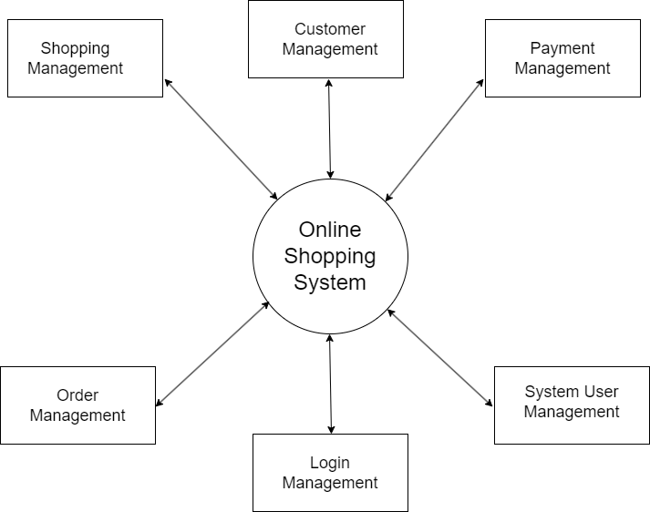

**Zero Level DFD - Flipkart**

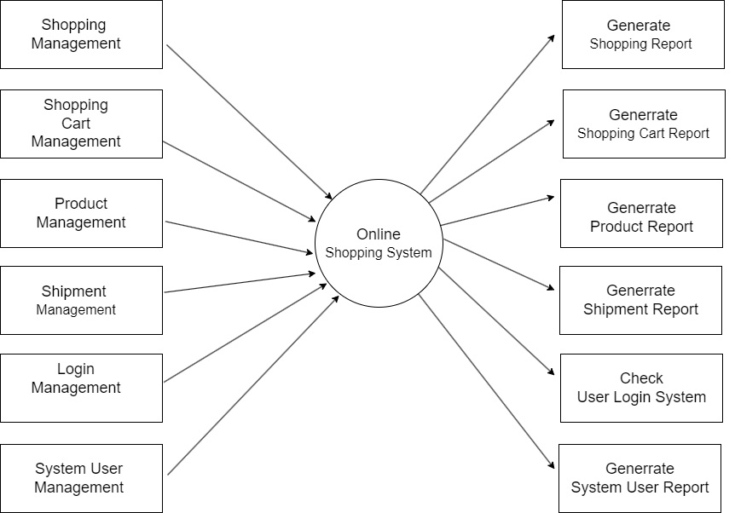

**First Level DFD - Flipkart**

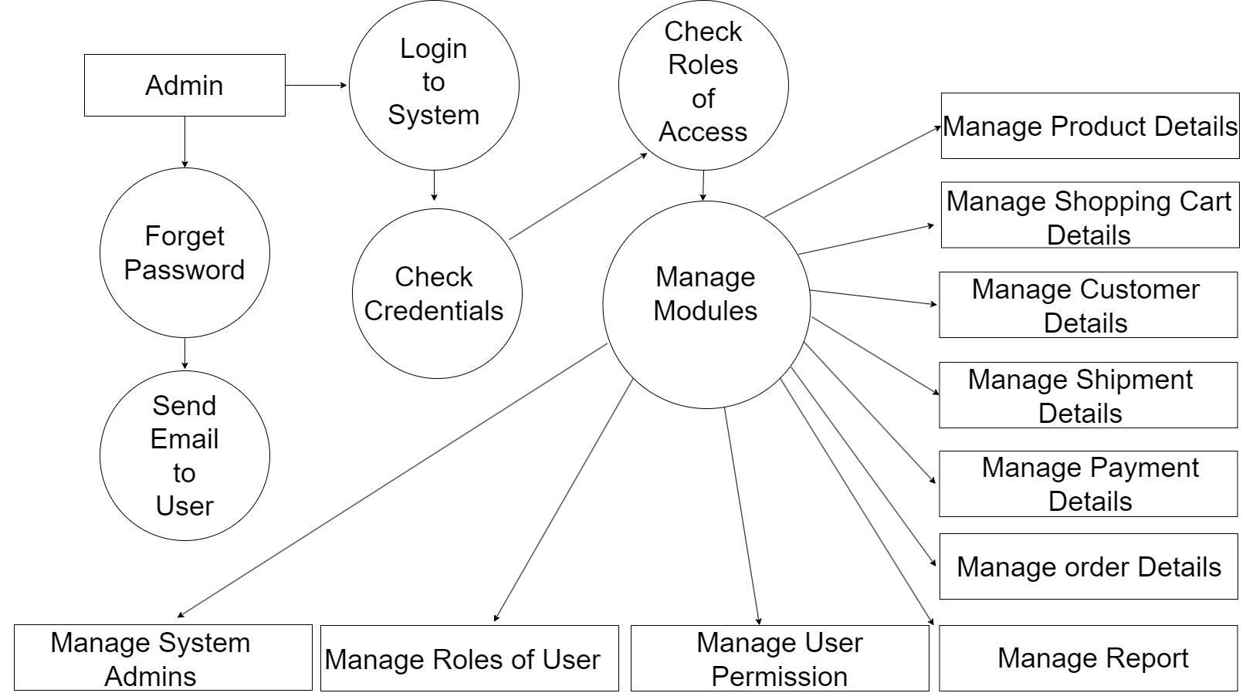

**Second Level DFD - Flipkart**

**Q 5. What is Flow chart? Create a flowchart to make addition of two numbers**

**Ans.** A flowchart is a type of diagram that represents a workflow or process. A flowchart can also be defined as a diagrammatic representation of an algorithm, a step-by-step approach to solving a task.

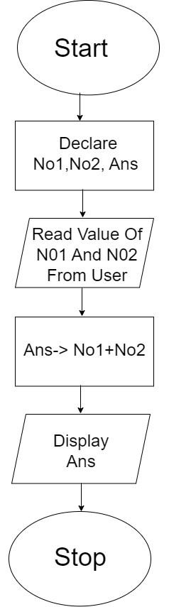

**Q 6. What is Use case Diagram? Create a use-case on bill payment on Paytm**

**Ans.** A Use Case Diagram is a type of Unified Modeling Language (UML) diagram that represents the interaction between actors (users or external systems) and a system under consideration to accomplish specific goals. It provides a high-level view of the system’s functionality by illustrating the various ways users can interact with it.



